Background on the child’s participation in Finnish-language activities Date
Surname and first names of the child:
Name normally used (or how the name is pronounced):
Date of birth: Place of birth:
Mother tongue(s):
Previous participation in Finnish-language activities (place, time, date–date):
Starting time in the current ECEC place/group (date and place):
Participation: club / part-time / full-time / other, which:
Attendance is regular / attendance is irregular , please specify:
Periods of absence outside holiday periods and their durations:
Notes
Place of assessment, assessor, date:

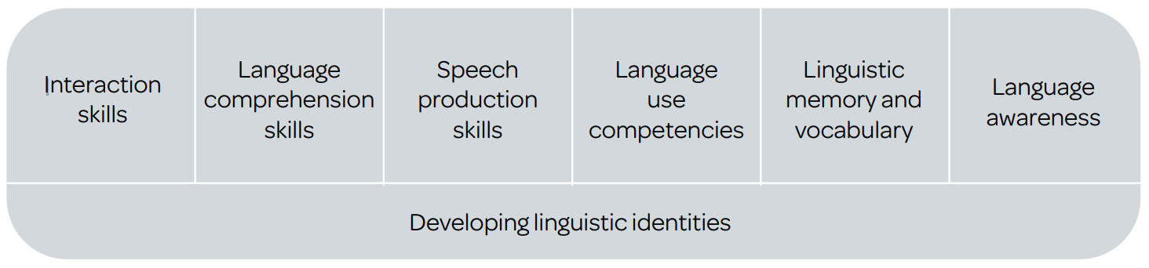
Figure 1. The main areas of children’s linguistic development in early childhood education and care
(National Core Curriculum for ECEC 2018, 44).

“The language skills of foreign language speaking and plurilingual children, as well as the development of their linguistic and cultural identities and self-esteem, are supported in early childhood education and care. The development of Finnish/ Swedish skills is promoted with a goal-oriented approach in different areas of linguistic skills and capacity based on the needs and capabilities of children. Versatile interactive situations and learning environments are used to provide the children with opportunities to use and learn Finnish/Swedish as a second language. Concrete everyday language and its resource of expressions are the starting point for learning the Finnish/Swedish language. Language comprehension and production skills develop in connection with one another. Children learn to make observations as well as express their ideas, emotions, and opinions in a manner that is suitable for the situation and natural to them.” (National Core Curriculum for ECEC 2018, 53.)

“Skills in interaction situations: Listening comprehension and speaking are closely linked in authentic interaction. Rather than being a monologue, speaking means functioning in an interaction situation where a person has to be able to react to the activities of his or her partners in the interaction. This requires listening comprehension and the skills to interpret the interaction situation.” “The student’s age, proficiency in his or her mother tongue and school background affect the amount of knowledge of the world and strategic skill the student has to exceed the limits of his or her language proficiency.” (Language proficiency scale 2016.)

